CS 255 System Design Document

UML Diagrams

UML Use Case Diagram
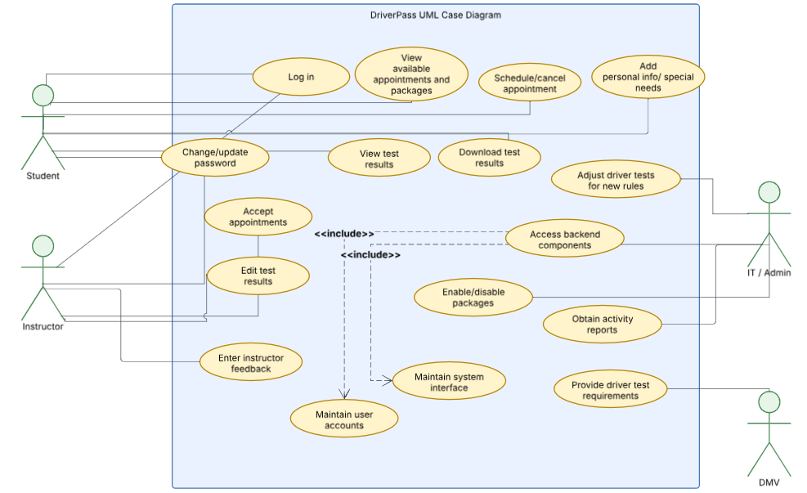

UML Activity Diagrams
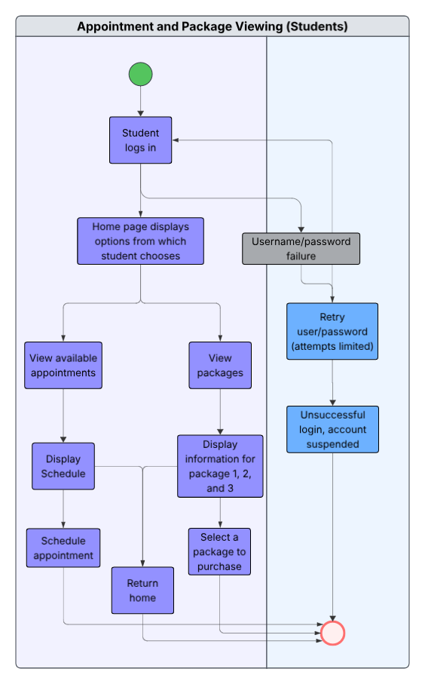
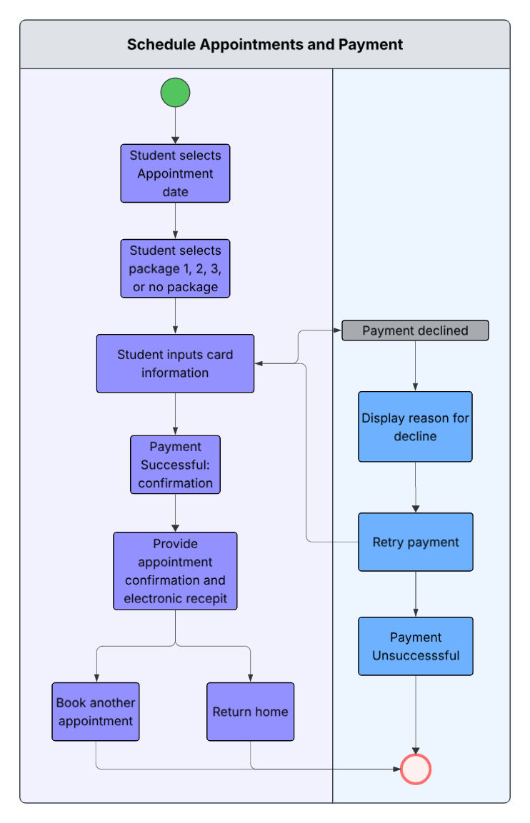

UML Sequence Diagram
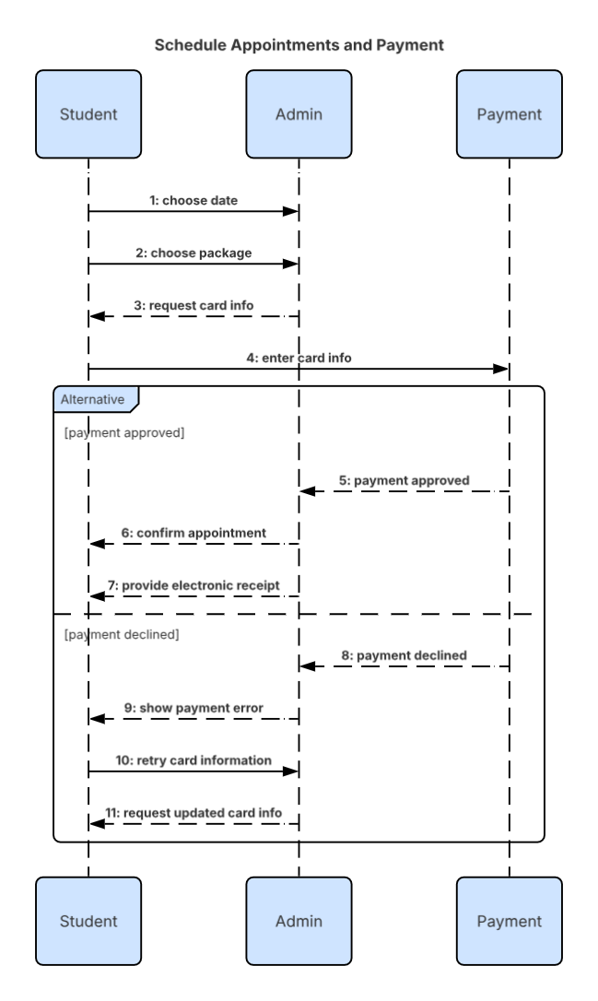

UML Class Diagram

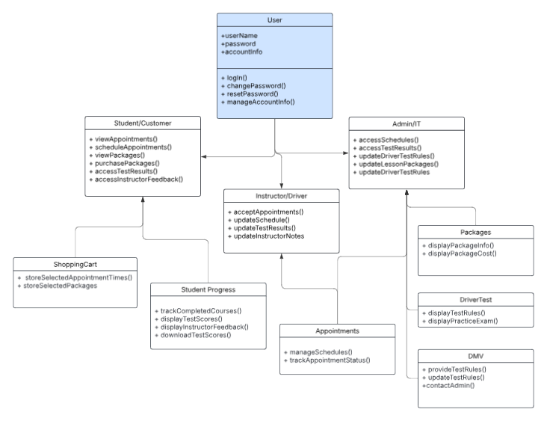

Technical Requirements
Hardware Requirements: This system will require users to have a desktop computer, laptop, or mobile device such as a smart phone or tablet that is capable of accessing the internet. The core hardware components for this system exist in the cloud or a data hosting center. The backend hardware components would consist of a processor, memory, storage, and network. It is important there is an established internet connection, otherwise the system will not run due to risk of double-booking among other variables.

Software requirements: On the backend side, software requirements include an operating system such as Linux, runtime environment such as JDK or JRE, application frameworks, and a database management system such as SQL to handle bookings, schedules, test logs, and user accounts. Users will need to have an operating system on their device such as Windows, macOS, or Linux and access to a modern web browser. External software components include a payment processing gateway, external DMV interface, and an email/text gateway to provide customers with booking confirmations.

Necessary tools: The tools needed for this system are IDE’s to create and debug the backend application code, some kind of build automation and dependency management for external packages, and tools for communication and collaboration between team members.

Necessary infrastructure: A cloud-based hosting environment is so the system is not relying on physical machines. To protect user communication and ensure steady traffic flow, the system would use infrastructure such as a domain name system and content delivery network, a load balancer, transport layer security, and a virtual private cloud/firewalls. There will also need to be automated backup storage in case of lost data, and an error monitoring layer to assess and resolve critical runtime errors and unauthorized access attempts.

